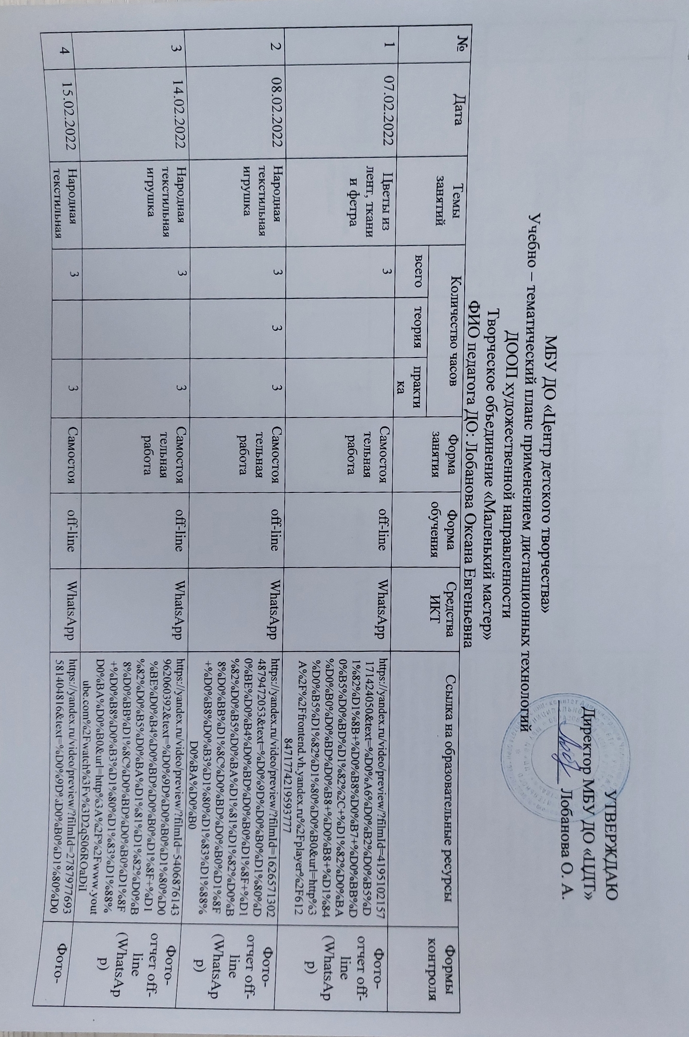

|  |  |  |  |  |  |  |  |  |  |  |
| --- | --- | --- | --- | --- | --- | --- | --- | --- | --- | --- |
| 4 | 15.02.2022 | Народная текстильная игрушка | 3 |  | 3 | Самостоятельная работа | off-line | WhatsApp | https://yandex.ru/video/preview/?filmId=2787977693581404816&text=%D0%9D%D0%B0%D1%80%D0%BE%D0%B4%D0%BD%D0%B0%D1%8F+%D1%82%D0%B5%D0%BA%D1%81%D1%82%D0%B8%D0%BB%D1%8C%D0%BD%D0%B0%D1%8F+%D0%B8%D0%B3%D1%80%D1%83%D1%88%D0%BA%D0%B0&url=http%3A%2F%2Fwww.youtube.com%2Fwatch%3Fv%3DOuZNtXO1YhA | Фото-отчет off-line (WhatsApp) |
| 5 | 21.02.2022 | Народная текстильная игрушка | 3 | 3 | 3 | Самостоятельная работа | off-line | WhatsApp | https://yandex.ru/video/preview/?filmId=16265713024879472053&text=%D0%9D%D0%B0%D1%80%D0%BE%D0%B4%D0%BD%D0%B0%D1%8F+%D1%82%D0%B5%D0%BA%D1%81%D1%82%D0%B8%D0%BB%D1%8C%D0%BD%D0%B0%D1%8F+%D0%B8%D0%B3%D1%80%D1%83%D1%88%D0%BA%D0%B0 | Фото-отчет off-line (WhatsApp) |
| 6 | 22.02.2022 | Народная текстильная игрушка | 3 |  | 3 | Самостоятельная работа | off-line | WhatsApp | https://yandex.ru/video/preview/?filmId=5406876143962060392&text=%D0%9D%D0%B0%D1%80%D0%BE%D0%B4%D0%BD%D0%B0%D1%8F+%D1%82%D0%B5%D0%BA%D1%81%D1%82%D0%B8%D0%BB%D1%8C%D0%BD%D0%B0%D1%8F+%D0%B8%D0%B3%D1%80%D1%83%D1%88%D0%BA%D0%B0&url=http%3A%2F%2Fwww.youtube.com%2Fwatch%3Fv%3D2qS06ROaDiI | Фото-отчет off-line (WhatsApp) |
| 7 | 28.02.2022 | Народная текстильная игрушка | 3 |  | 3 | Самостоятельная работа | off-line | WhatsApp | https://yandex.ru/video/preview/?filmId=2787977693581404816&text=%D0%9D%D0%B0%D1%80%D0%BE%D0%B4%D0%BD%D0%B0%D1%8F+%D1%82%D0%B5%D0%BA%D1%81%D1%82%D0%B8%D0%BB%D1%8C%D0%BD%D0%B0%D1%8F+%D0%B8%D0%B3%D1%80%D1%83%D1%88%D0%BA%D0%B0&url=http%3A%2F%2Fwww.youtube.com%2Fwatch%3Fv%3DOuZNtXO1YhA | Фото-отчет off-line (WhatsApp) |