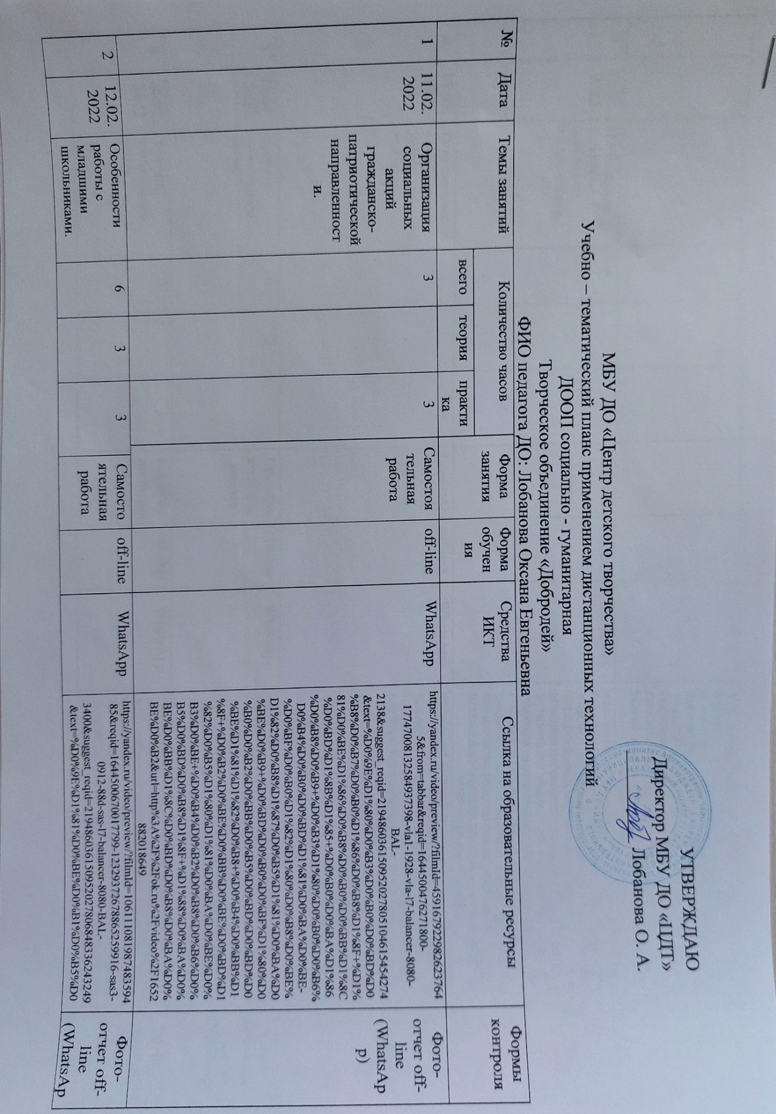

|  |  |  |  |  |  |  |  |  |  |  |
| --- | --- | --- | --- | --- | --- | --- | --- | --- | --- | --- |
| 2 | 12.02.2022 | Особенности работы с младшими школьниками. | 6 | 3 | 3 | Самостоятельная работа | off-line | WhatsApp | https://yandex.ru/video/preview/?filmId=10611108198748359485&reqid=1644500670017799-12329372678865259916-sas3-0912-88d-sas-l7-balancer-8080-BAL-3400&suggest_reqid=219486036150952027806848336243249&text=%D0%9E%D1%81%D0%BE%D0%B1%D0%B5%D0%BD%D0%BD%D0%BE%D1%81%D1%82%D0%B8+%D1%80%D0%B0%D0%B1%D0%BE%D1%82%D1%8B+%D1%81+%D0%BC%D0%BB%D0%B0%D0%B4%D1%88%D0%B8%D0%BC%D0%B8+%D1%88%D0%BA%D0%BE%D0%BB%D1%8C%D0%BD%D0%B8%D0%BA%D0%B0%D0%BC%D0%B8+%D0%B2+%D0%B2%D0%BE%D0%BB%D0%BE%D0%BD%D0%B5%D1%80%D1%81%D1%82%D0%B2%D0%B5&url=http%3A%2F%2Fwww.youtube.com%2Fwatch%3Fv%3DzgyKiGjikS8 | Фото-отчет off-line (WhatsApp) |
| 3 | 18.02.2022 | Особенности работы с младшими школьниками. | 6 |  | 3 | Самостоятельная работа | off-line | WhatsApp | https://yandex.ru/video/preview/?filmId=430956882187710919&text=%D0%B2%D0%B8%D0%B4%D0%B5%D0%BE+%D0%9E%D1%81%D0%BE%D0%B1%D0%B5%D0%BD%D0%BD%D0%BE%D1%81%D1%82%D0%B8+%D1%80%D0%B0%D0%B1%D0%BE%D1%82%D1%8B+%D1%81+%D0%BC%D0%BB%D0%B0%D0%B4%D1%88%D0%B8%D0%BC%D0%B8+%D1%88%D0%BA%D0%BE%D0%BB%D1%8C%D0%BD%D0%B8%D0%BA%D0%B0%D0%BC%D0%B8+%D0%B2+%D0%B2%D0%BE%D0%BB%D0%BE%D0%BD%D1%82%D0%B5%D1%80%D1%81%D1%82%D0%B2%D0%B5&url=http%3A%2F%2Fwww.youtube.com%2Fwatch%3Fv%3De4Ltq8TQsNM | Фото-отчет off-line (WhatsApp) |
| 4 | 19.02.2022 | Психологические особенности людей пожилого возраста | 3 |  | 3 | Самостоятельная работа | off-line | WhatsApp | https://yandex.ru/video/preview/?filmId=2313430298127832757&text=%D0%9F%D1%81%D0%B8%D1%85%D0%BE%D0%BB%D0%BE%D0%B3%D0%B8%D1%87%D0%B5%D1%81%D0%BA%D0%B8%D0%B5+%D0%BE%D1%81%D0%BE%D0%B1%D0%B5%D0%BD%D0%BD%D0%BE%D1%81%D1%82%D0%B8+%D0%BB%D1%8E%D0%B4%D0%B5%D0%B9+%D0%BF%D0%BE%D0%B6%D0%B8%D0%BB%D0%BE%D0%B3%D0%BE+%D0%B2%D0%BE%D0%B7%D1%80%D0%B0%D1%81%D1%82%D0%B0+%D0%B2%D0%B8%D0%B4%D0%B5%D0%BE+%D0%B4%D0%BB%D1%8F+%D0%B4%D0%B5%D1%82%D0%B5%D0%B9&url=http%3A%2F%2Fwww.youtube.com%2Fwatch%3Fv%3D-PTR7loWbj4 | Фото-отчет off-line (WhatsApp) |
| 5 | 25.02.2022 | Тренинг личностного роста. | 6 | 3 |  | Самостоятельная работа | off-line | WhatsApp | https://yandex.ru/video/preview/?filmId=17803473843873154488&text=%D1%82%D1%80%D0%B5%D0%BD%D0%B8%D0%BD%D0%B3+%D0%BB%D0%B8%D1%87%D0%BD%D0%BE%D1%81%D1%82%D0%BD%D0%BE%D0%B3%D0%BE+%D1%80%D0%BE%D1%81%D1%82%D0%B0+%D0%B4%D0%BB%D1%8F+%D0%BF%D0%BE%D0%B4%D1%80%D0%BE%D1%81%D1%82%D0%BA%D0%BE%D0%B2 | Фото-отчет off-line (WhatsApp) |
| 6 | 26.02.2022 | Тренинг личностного роста. | 3 |  | 3 | Самостоятельная работа | off-line | WhatsApp | https://yandex.ru/video/preview/?filmId=9457575750672217991&text=%D1%82%D1%80%D0%B5%D0%BD%D0%B8%D0%BD%D0%B3+%D0%BB%D0%B8%D1%87%D0%BD%D0%BE%D1%81%D1%82%D0%BD%D0%BE%D0%B3%D0%BE+%D1%80%D0%BE%D1%81%D1%82%D0%B0+%D0%B4%D0%BB%D1%8F+%D0%BF%D0%BE%D0%B4%D1%80%D0%BE%D1%81%D1%82%D0%BA%D0%BE%D0%B2 | Фото-отчет off-line (WhatsApp) |